Databases — Part 3
Keys & Foreign Keys — a Deep Dive
Daniel Ude • Facilitator, ICBM Technical Bootcamp
Back-End Class — Continued

1. The Concept of Keys
Whenever we talk about identifying keys (candidate and primary keys), the first thing to remember is that they must be unique — recall the three core features of a primary key: it is unique, it is never null, and it should never change (it is meant to be a stable, permanent anchor). Foreign keys are the one exception: they point at a unique parent key, but they deliberately repeat across many child rows.
Important framing
All the key “types” below are for descriptive purposes only. You will never see an RDBMS ask you to select a “kind” of key. You simply define a PRIMARY KEY, UNIQUE constraints, and FOREIGN KEY references — and we use these names to describe the role each one plays.
And as a headline that we will justify shortly: your primary key should ideally be a surrogate key.

2. The Roles a Key Can Play
Quick correction
The notes said “four kinds of keys” but then only really listed one. Here is the coherent picture: a key plays one of four roles — Candidate, Primary, Alternate, or Foreign — and Natural vs Surrogate simply describes where a key’s value comes from, not a separate category.
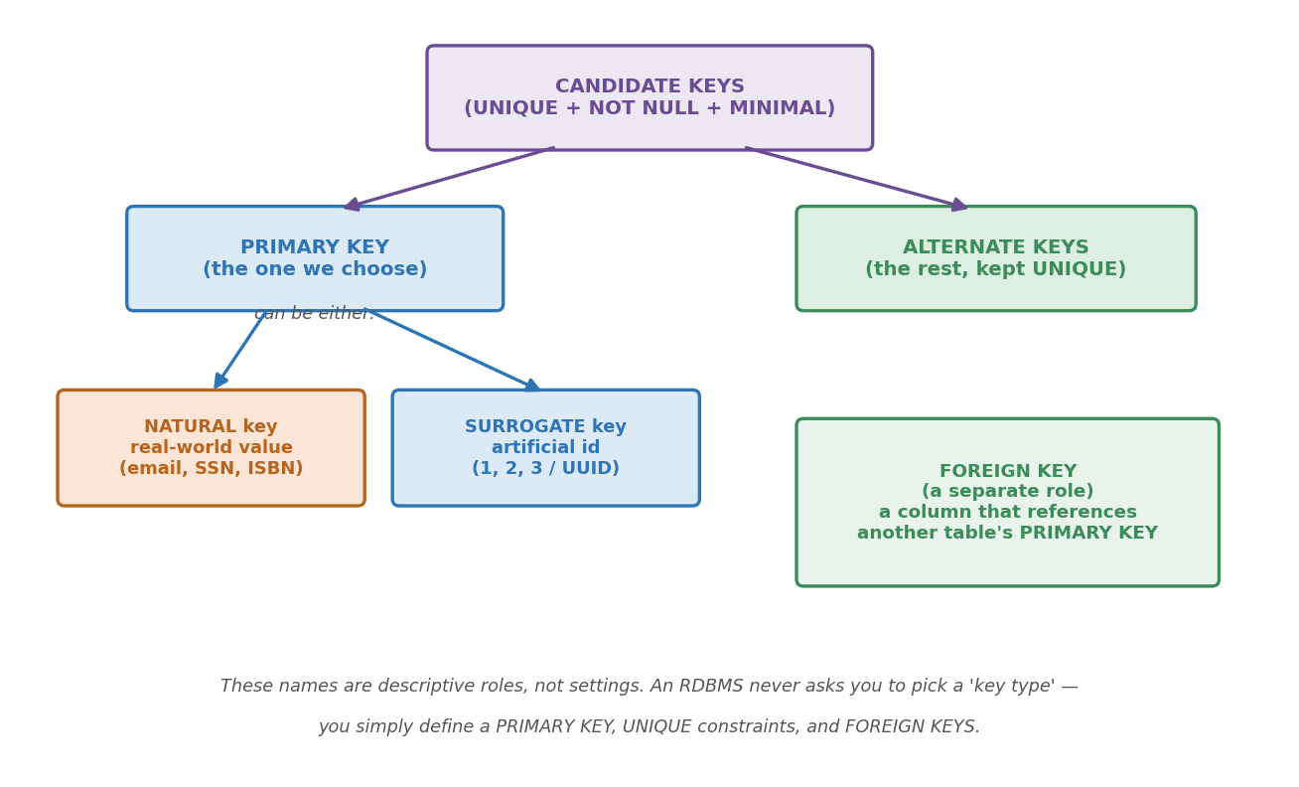
Figure 1. How the key roles relate to one another.

Candidate Keys — the pool
A candidate key is any column (or set of columns) that meets all three criteria of a primary key:
- UNIQUE — it cannot identify a specific row if there are duplicates.
- NOT NULL — it cannot be empty.
- MINIMAL — it uses the absolute minimum number of columns necessary to stay unique (no extra padding columns).
Every column that qualifies is a “candidate” — they are all eligible for the top job, like primaries before an election.

What “minimal” means — an example
“Minimal” means a candidate key uses the fewest columns needed to stay unique. If you can drop a column and the key is still unique, it was not minimal.
Case 1 — minimal is a single column. Take a students table with student_id, email, first_name, last_name:
- {student_id} → unique on its own; minimal.
- {email} → also unique on its own; minimal.
- {student_id, email} → still unique, but not minimal: drop email and student_id alone still identifies the row. That combination is a super key, not a candidate key.
Case 2 — minimal can be more than one column. Take the enrollments bridge table (student_id, course_id):
- {student_id} alone → not unique (a student takes many courses).
- {course_id} alone → not unique (a course has many students).
- {student_id, course_id} together → unique, and you cannot drop either one. This is a minimal composite candidate key.

Composite Keys
What then is a composite key? In our many-to-many relationship, suppose we had a table like this:
Enrollment Table (Surrogate Key Only)
id (PK) | student_id (FK) | course_id (FK) | grade
300 | 1 (Obasi) | 101 (Maths) | A
301 | 1 (Obasi) | 101 (Maths) | A
302 | 1 (Obasi) | 101 (Maths) | A

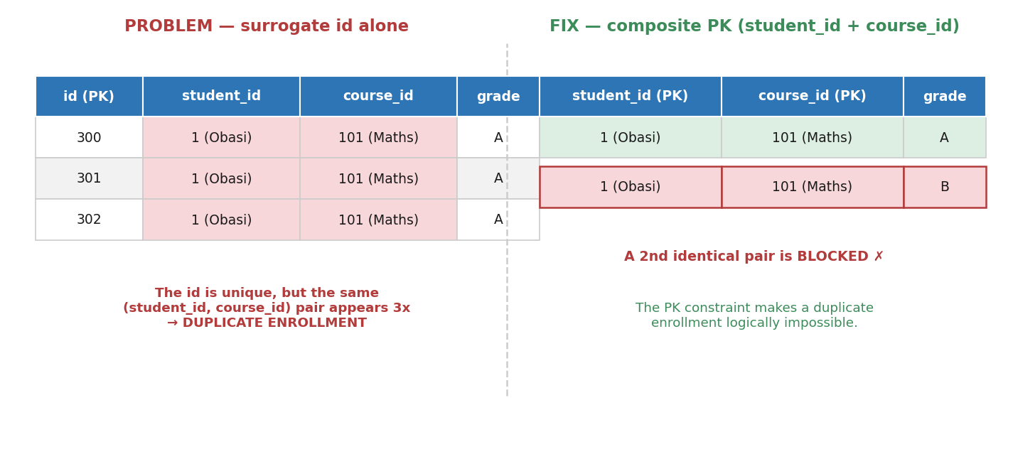
The surrogate id is unique, but the (student_id, course_id) pair repeats — a duplicate enrollment.
Can we see that technically this is correct, in the sense that our PK meets the three conditions that it needs to meet. But notice that our FK data, although technically allowed (we are permitted to repeat foreign keys), is wrong here — and this is simply because we have three rows where the key columns are all the same.
Now, there are two ways we can solve this issue.
A. Composite keys. This is when we use two or more attributes together as a PK. However, to do this, we need to go through the 3-Step Architect’s Test:
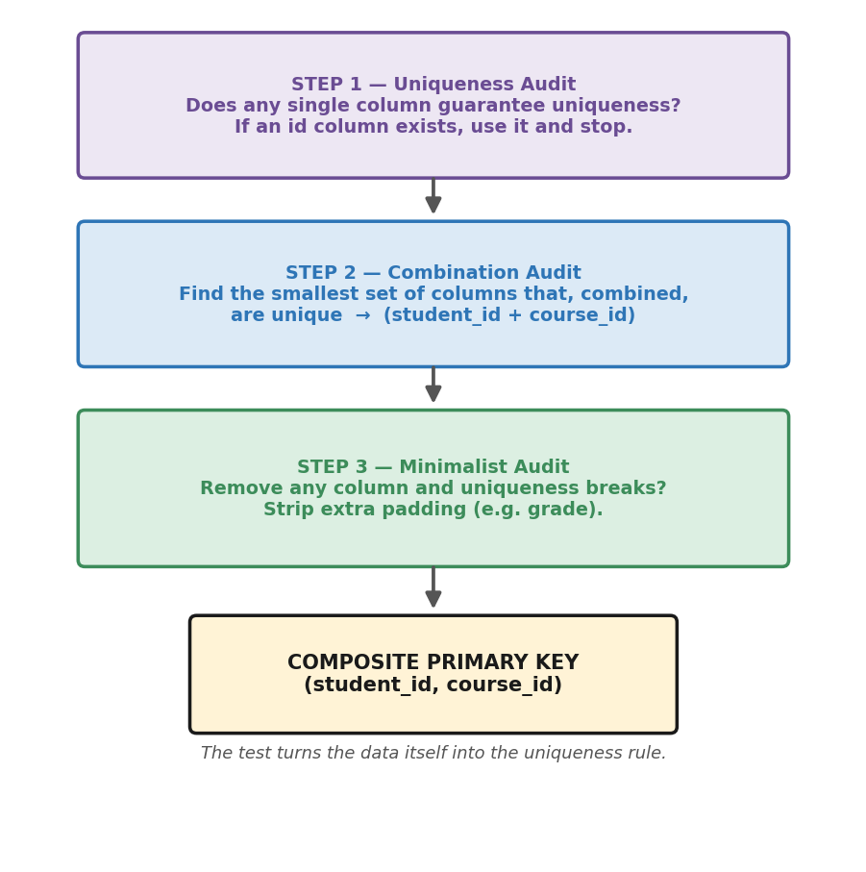
The 3-step test for finding a composite key.
Step 1 — the “Uniqueness” Audit. Look at your columns. Do any of them individually guarantee that a row will never be a duplicate? If you have an id column (like an auto-incrementing integer), stop! Use that as your primary key. It’s simple, unique, and perfect.
Now let us also assume that our enrollments table has no id column. Can I find a unique row by looking at one column?
- student_id? No, it repeats.
- course_id? No, it repeats.
Step 2 — the “Combination” Audit. Since no single column works, you start looking for the smallest set of columns that, when combined, create a unique “fingerprint” for every row. You pair them up: (student_id + course_id). Then you test the data: is there any scenario where Obasi (Student 1) can take Maths (Course 101) twice? If the answer is “No, that should be impossible,” then you have found your candidate key.
Step 3 — the “Minimalist” Audit. This is the final hurdle to ensure it’s a candidate key and not just a superkey. You must be able to say: “If I remove any of these columns, I lose uniqueness.” If you used (student_id, course_id, grade) as a key, you would ask: do I need grade to identify the row? No — if I have the student and the course, I already know which row it is. Therefore, grade is “extra padding.” You strip the extra padding away until you are left with the smallest possible group. That group is your composite primary key.
Note: this assumes a student enrols in a given course only once. If retakes are allowed, (student_id, course_id) is no longer unique, and you would add a column such as semester (or rely on the surrogate id) to tell the two attempts apart.

Superkey vs Candidate Key
What then is the difference between a superkey and a candidate key? Easy. A superkey is anything that passes the uniqueness test, whether it is a composite key or not. An example of a superkey would include:
- (student_id)
- (email)
- (student_id, first_name)
- (student_id, last_name)
- (email, first_name, last_name)
- (student_id, email, first_name, last_name) …and many more combinations.
All six of those are superkeys. Now, a candidate key is a superkey that has passed the minimal test. It is the absolute smallest set of columns required to uniquely identify a row. If you remove even a single column from a candidate key, the uniqueness breaks.
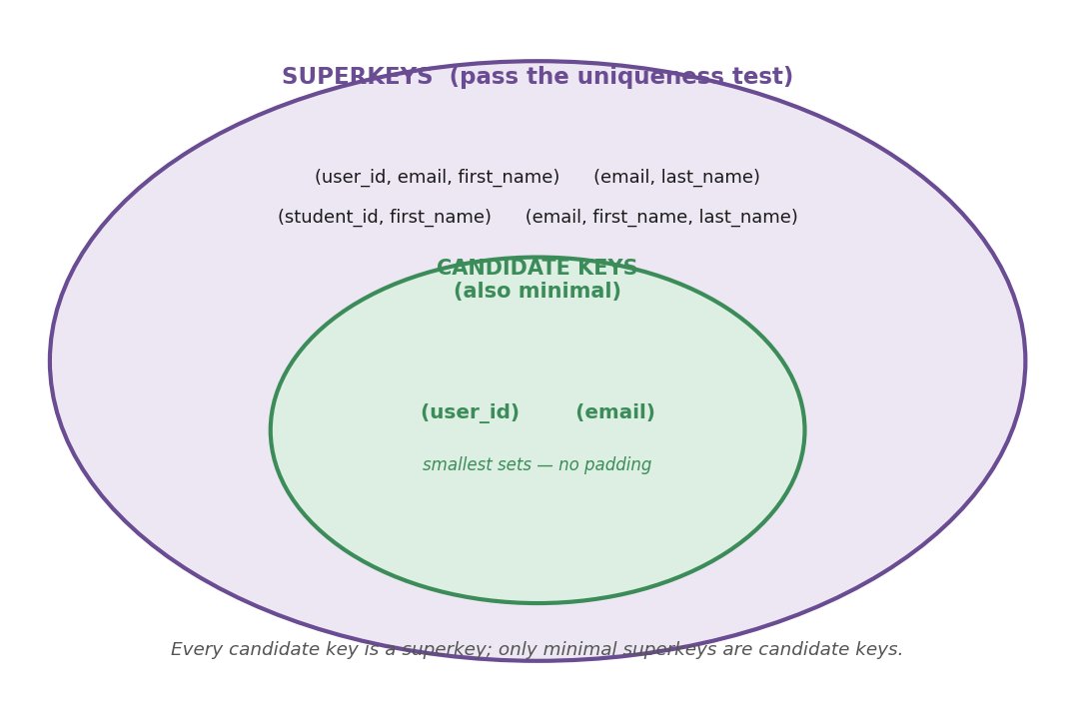
Every candidate key is a superkey, but only minimal superkeys are candidate keys.
Imagine a Users table with the following columns: user_id, email, first_name, and last_name. Let’s test different combinations to see if they are superkeys or candidate keys:
Combination A: (user_id, email, first_name)
- Is it unique? Yes. No two people will have the exact same ID, email, and first name. Therefore, it is a superkey.
- Is it minimal? No. You don’t need the first name or the email to identify the row; the user_id does that job perfectly on its own. Because it has extra padding, it is not a candidate key.
Combination B: (email, last_name)
- Is it unique? Yes. Every email is unique, so adding the last name keeps the combination unique. It is a superkey.
- Is it minimal? No. You can remove last_name and the email alone is still unique. Because last_name is unnecessary padding, this is not a candidate key.
Combination C: (user_id)
- Is it unique? Yes.
- Is it minimal? Yes! You cannot strip away any more columns. It is stripped down to the absolute bare essentials. Therefore, it officially graduates from being just a superkey to being a candidate key.
Combination D: (email)
- Is it unique? Yes.
- Is it minimal? Yes. Just like the ID, you cannot remove anything else. This is your second candidate key.
So, we can use composite keys to ensure data integrity — so that we do not end up with a repeating combination of values. If we use (student_id, course_id) as the primary key, we ensure that the same student–course pair never repeats again. (The individual columns may still repeat on their own; it is the pair that cannot.)
- Why use it? You are letting the data itself define the uniqueness. You are telling the database: “There is no such thing as an enrollment record unless a student is paired with a course.”
- The benefit: it is “cleaner” because you don’t have an extra id column taking up space. It is logically impossible to have a duplicate enrollment, because the primary-key constraint itself won’t allow it.
B. On the other hand, we have the second design where, for the sake of simplicity, we simply use a surrogate key as the primary id.
Primary Key: id (300, 301, 302…)
- Why use it? It’s incredibly fast for the database to look up a single number.
- The problem: as we discussed, this doesn’t automatically stop a user from accidentally registering for the same course twice.
- The architect’s fix: you keep the id as the primary key, but you add a UNIQUE constraint on the (student_id, course_id) pair. This gives you the best of both worlds: a simple ID for the database to use, and a “logical guardrail” that prevents duplicates.
My recommendation
Personally, I prefer a hybrid approach: use the surrogate key as the PK, and then apply a UNIQUE constraint on the (student_id, course_id) pair.
Quick test
Remove each column one at a time. If the key is still unique after a removal, it was not minimal.

Primary Key — the one we choose
From the pool of candidates, we choose exactly one to be the primary key. That chosen key can be sourced in one of two ways: as a natural key or a surrogate key.

The Natural Key (real-world data)
A natural key is a column that already exists in the real world and carries a logical, built-in meaning to the user, while also being perfectly unique.
- Examples: an email address, a person’s Social Security Number (SSN), a car’s license plate, or a book’s ISBN barcode.
- If you make email_address your primary key, you are using a natural key for the job.

The Surrogate Key (artificial id)
A surrogate key is a completely artificial, meaningless number or string invented by the database purely to identify the row. It has no connection to the real world.
- Examples: an auto-incrementing integer (id: 1, 2, 3...) or a random UUID (a1b2c3d4...).
- If you create a brand-new student_id column just to number your rows, you are using a surrogate key. It has no real-world meaning; it is just an id for your table.

Alternate Keys — the runners-up
Once we select a primary key (natural or surrogate), every other candidate key that still meets the criteria becomes an alternate key. We usually keep these as UNIQUE constraints so they still prevent duplicates.

A worked example
Column | Key role | Constraint / Rule
id | Surrogate | PRIMARY KEY (used for JOINs and foreign keys)
username | Natural (Alternate) | UNIQUE (prevents duplicate profiles)
email | Natural (Alternate) | UNIQUE (prevents duplicate logins / spam)
phone_number | Natural (Alternate) | UNIQUE (prevents SMS fraud / duplicate 2FA)

3. Why the Primary Key Should Be a Surrogate
We want our primary key to never change, to be unique, and to never be null. You may well find natural keys that meet these criteria — username is unique and not null — but here is the problem you run into.
The example. Suppose we use the natural key username as a primary key, and other tables reference it as a foreign key. The moment a user changes or updates their username, that value has to be rewritten across every table that points to it. If that username appears in 6,500 related rows, all 6,500 must be updated.
Had we used a surrogate key instead (say id: 42), the database would only update the one text field in the Users table. The id remains 42, and the 6,500 related rows are never touched.
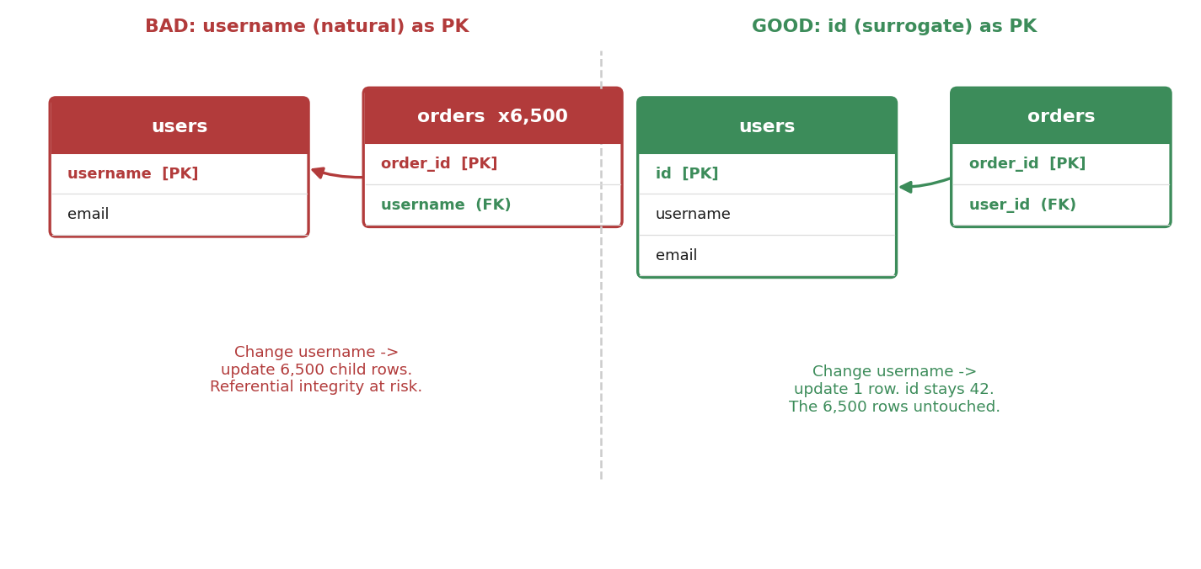
Figure 2. A natural-key change ripples to every child row; a surrogate id stays put.
Consistency rule
Whichever convention you choose, stick to it. If the Users table uses a surrogate key, but Products uses a natural key like an SKU, and Stores uses a Store Number, it becomes a nightmare to write predictable ORM models or SQL joins. And if you use a surrogate key, it should never carry any real-world value.

4. Foreign Keys
The most basic definition: a foreign key is a reference — and what it references is a primary key. Its whole purpose is to enforce referential integrity, which we covered last class as the heart of data integrity.

Why still validate in the backend if the database has constraints?
If we already have UNIQUE constraints at the database level, why rely on Pydantic to validate as well? Because leaning solely on the database to catch errors is slow, and the error it throws is fatal and ugly. If a user registers with an email that already exists, the database raises a hard constraint-violation error. Rather than let the application crash, a robust backend uses validation models (like Pydantic) to check these constraints before the SQL query ever runs. The API layer checks whether the email or username exists and, if so, gracefully returns a 400 Bad Request with a helpful message like “This email is already taken.” The database constraint remains the final safety net; validation is for a graceful user experience.

Why we need foreign keys
Table 1 — Users (the parent):
id (PK) | first_name | email (Alternate Key)
1 | Alice | alice@gmail.com
2 | Bob | bob@yahoo.com

Table 2 — Orders (the child):
order_id (PK) | product | user_id (Foreign Key)
101 | Laptop | 1
102 | Mouse | 1
103 | Keyboard | 2

Pop quiz
What kind of table is Orders, and why?
Answer: it is the child table, and it sits on the “many” side of a one-to-many relationship — one user can have many orders, but each order belongs to exactly one user. We know it is the child because it holds the foreign key (user_id).

Reading “the reference”
Notice the Orders table does not store Alice’s name or her email. It only stores a 1. That 1 is the foreign key. Its only job is to point a finger directly at the primary key in the Users table and say: “Whoever is at ID #1, this order belongs to them.”

Referential integrity in action
Scenario A — the ghost order. What if I try to insert a new order but set user_id to 99? The database throws an error and blocks the insert, because there is no User #99. The foreign-key rule says: you cannot reference something that does not exist. The database refuses to create an orphan order floating in the void.
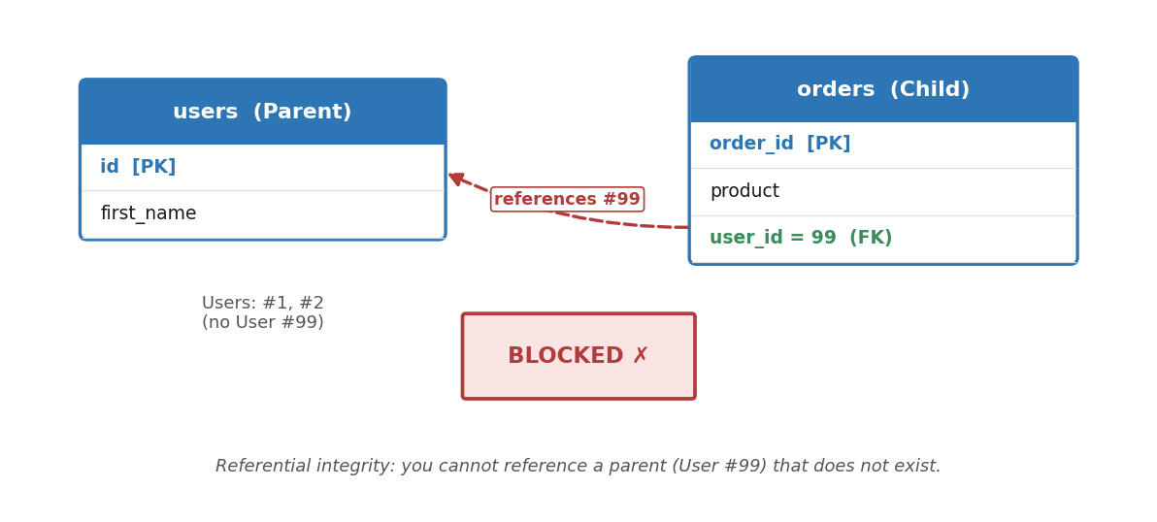
Figure 3. An order referencing User #99 is blocked — no such parent exists.
Scenario B — the accidental deletion. What if Alice (User #1) deletes her account, but we have not dealt with her laptop and mouse orders first? The database blocks the deletion. The foreign key protects the parent just as much as the child: “Orders 101 and 102 reference User #1. If I delete User #1, those orders point to nothing. I will not allow this until you decide what to do with the children.” By default, then, you must handle the child rows before you touch the parent.
But forcing a developer to manually delete 10,000 child rows before removing a ten-year customer’s account is wildly inefficient. That is exactly what referential actions automate — covered in Section 7.

5. NOT NULL and the Foreign Key
NOT NULL simply means a column cannot be empty: for every row, that column must hold a value. This matters for foreign keys because if we mark an FK column as NOT NULL, then every row must reference a parent — the relationship becomes mandatory. Leave NOT NULL off, and the relationship becomes optional.

The optional, self-referencing case
Consider an Employees table where every employee has a manager_id — a foreign key pointing to another employee in the same table. What happens when you add the CEO? The CEO has no manager. If manager_id were NOT NULL, you could never save the CEO’s profile. Because we leave NOT NULL off, the CEO’s manager_id can safely be left empty (NULL). In other words, the architect can deliberately turn NOT NULL off when there is a good reason to.
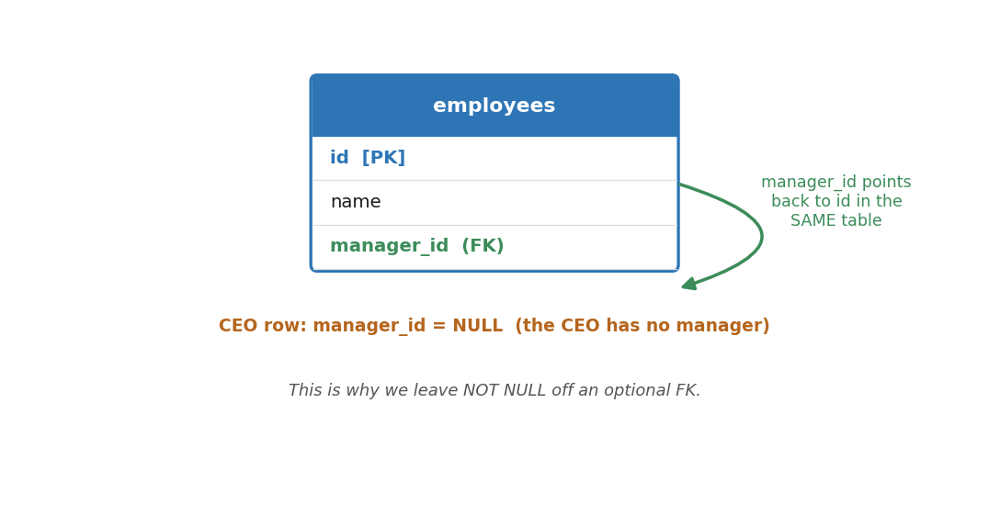
Figure 4. A self-referencing FK; the CEO’s manager_id is NULL.
And note: a table has exactly one primary key, but it can have many foreign keys, each referencing a different table.

6. PK vs FK — Why a Foreign Key Can Change
A primary key should never change, but a foreign key can change — simply because real-world references change. There are two reasons.

Reason 1 — the business reality changed (reassignment)
A foreign key is just a pointer: “this child belongs to that parent.” In the real world, relationships shift constantly. Imagine an Employees table where Charlie (an intern) has manager_id = 2 (Bob). Next week Bob moves departments and Alice takes over his team. Charlie’s manager_id must change from 2 to 1. The foreign key changed because the relationship changed — and referential integrity is still perfectly intact, because Charlie still points to a valid manager.

Reason 2 — the parent changed (cascading updates)
Remember the cascading-update anomaly. If we use a natural key like username as a primary key and Alice changes hers from Alice123 to Alice_Dev, the primary key itself changes. If the foreign key in Orders kept saying Alice123, it would now point to a ghost, and referential integrity would break. To prevent that, the architect uses ON UPDATE CASCADE: “If the primary key ever changes, immediately update every foreign key that points to it, so the connection never breaks.”
How can a foreign key change and still be safe?
A foreign key doesn’t change to break the rules — it changes to survive. It either changes because the business asked it to point to a new parent, or because its current parent moved and it has to update its reference to keep the data from breaking.

A subtle but important distinction
Suppose the manager for a group of interns changes from Alice to Joshua, and the manager’s reference appears 700 times. In that case you must update 700 rows regardless of whether you use a natural or surrogate key:
- Natural keys: you update 700 rows from “Alice” to “Joshua.”
- Surrogate keys: you update 700 rows from id 1 (Alice) to id 2 (Joshua).
Because a completely new boss took over, the relationship physically changed. A surrogate key does not magically save you from updates when a real-world reassignment happens — a foreign key references a real-life relationship.
The true danger of the natural key
Bad architecture (natural key): Joshua is the manager and his name is the primary key, appearing in 700 intern rows. Joshua legally shortens his name to “Josh.” Because his name is the key, you must now update all 700 rows just because one person edited his profile.
Good architecture (surrogate key): Joshua’s id (2) is the primary key. He shortens his name to “Josh.” You update his name once in the Employees table; his id stays 2, and the 700 intern rows are never touched.

7. Foreign-Key Constraints: ON DELETE & ON UPDATE
We use foreign-key constraints to protect referential integrity. The two we configure are ON DELETE and ON UPDATE. These terms are tied to SQL and the exact wording can differ between RDBMSs, but the concepts are the same everywhere.
When a parent table (holding the primary key) is bound to a child table (holding the foreign key), one architectural question follows: what should happen to the child rows if the parent’s key is deleted or updated? Each constraint can take one of three actions:
- RESTRICT — if any child is actively pointing at the parent, this screams do not let that happen. The database blocks the delete/update so we never get orphan rows. Handle the children first.
- CASCADE (the domino effect) — delete or update the parent and the database automatically applies the same change to every matching child. If the parent goes down, the children go with it.
- SET NULL (the disconnection) — delete or update the parent and the database sets the child’s foreign key to NULL. The child rows survive, but their pointer is wiped. This only works if you left NOT NULL off the FK column.
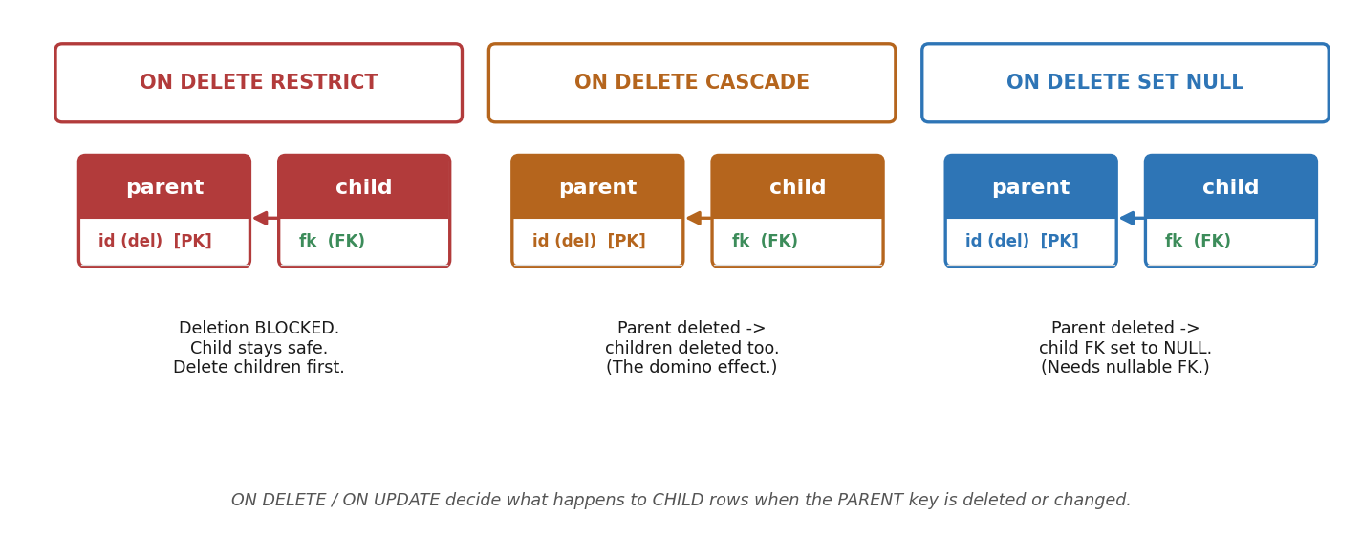
Figure 5. The three ON DELETE / ON UPDATE actions.

Scenario 1 — ON DELETE RESTRICT (the safety lock)
Rule: a user cannot be deleted if they have active orders; we keep order history for accounting. Alice (User #1) has 3 orders and clicks “Delete Account.” The engine sees 3 rows pointing to User #1 and blocks the deletion, keeping Alice’s profile intact so those orders never become ghost orders.

Scenario 2 — ON DELETE CASCADE (the domino)
Here the Orders table (parent) is linked to an Order_Items table (child) with ON DELETE CASCADE. We delete order_id = 10.
Before:
Orders — order_id (PK) | user_id
10 | 1
20 | 2

Order_Items — item_id (PK) | order_id (FK) | product_name | price
501 | 10 | Laptop | 1,200.00
502 | 10 | Mouse | 25.00
503 | 20 | Book | 45.00

Behind the scenes, in a fraction of a millisecond: the engine deletes order_id = 10; checks who depended on it; sees Order_Items linked with CASCADE; and instantly deletes every Order_Items row where order_id = 10 (the Laptop and the Mouse).
After (the clean slate):
Orders — order_id (PK) | user_id
20 | 2

Order_Items — item_id (PK) | order_id (FK) | product_name | price
503 | 20 | Book | 45.00

Why CASCADE saves engineers
With RESTRICT instead: the database would refuse to cancel the order until you manually deleted the laptop and mouse first — clunky code.
With no constraint at all: you delete Order #10 but the laptop and mouse linger forever pointing at a non-existent order — orphan rows wasting space and corrupting your metrics.

Scenario 3 — ON DELETE SET NULL (the graceful disconnection)
We have a holiday coupon (Coupon #200) that customers applied to past orders. When the holiday ends we want to delete the coupon, but we must not delete the orders, and we don’t want the deletion blocked. The Orders table’s coupon_id is nullable and configured with ON DELETE SET NULL. The admin deletes Coupon #200; the database then sweeps the Orders table and quietly changes coupon_id from 200 to NULL on those orders. The financial data stays perfectly safe — it just no longer points to a deleted coupon.

Summary cheat sheet
Referential Action | What happens to the Parent? | What happens to the Child? | Best used for
RESTRICT | Deletion is blocked | Nothing (stays safe) | Vital historical data (Customers & Orders)
CASCADE | Deletion is allowed | Child is deleted automatically | Dependent data (an Order & its Items)
SET NULL | Deletion is allowed | Child FK turns to NULL | Optional relationships (Orders & Coupons)

8. What You Can Always Touch
Rule 1 — the child (FK side) can always be updated or deleted. Deleting a child never breaks referential integrity. If you delete an order, the Users table doesn’t care; the parent user still exists. Deleting a child never creates an orphan, so the database will never block you.
Rule 2 — an unreferenced parent can also be deleted or updated freely. Even with RESTRICT turned on, if a particular primary key is not referenced by any foreign key, you can delete or update it instantly. RESTRICT only steps in when a child is actively holding the parent’s hand.
Whiteboard example
User #1 (Alice) has 5 orders pointing to her → cannot be deleted (RESTRICT blocks it; 5 orphans would result).
User #2 (Bob) signed up today with 0 orders → can be deleted instantly; his primary key is completely unreferenced.
“Constraints are not there to trap your data; they are there to protect it. A RESTRICT constraint only steps in when a deletion would cause damage. If a parent has no children depending on it, it is free to be deleted or updated at any time.”

9. A Final Gotcha — ON UPDATE vs ON DELETE
If you only configure ON UPDATE SET NULL and then try to delete the parent row, the database ignores the SET NULL rule entirely. The ON UPDATE action only governs updates. For deletes it falls back to the default ON DELETE behaviour — NO ACTION, which behaves like RESTRICT — and blocks you. Always set the action for the operation you actually intend.

Key Takeaways
- Key “types” are descriptive roles. You only ever declare PRIMARY KEY, UNIQUE, and FOREIGN KEY.
- Candidate keys are UNIQUE + NOT NULL + MINIMAL; the chosen one is the primary key, the rest are alternate keys.
- Prefer a surrogate primary key so a profile edit never ripples across thousands of child rows; keep natural keys as UNIQUE alternates, and be consistent.
- A foreign key references a primary key and enforces referential integrity: no child without a parent, and no parent deleted while children remain.
- NOT NULL makes a relationship mandatory; leaving it off makes it optional (and is required for SET NULL).
- Control deletes/updates with RESTRICT, CASCADE, or SET NULL — and set the action for the operation you actually intend.

